Al Ain Launch Campaign Performance

## **1. Video View Campaign:**

| Day | Ad group | Views | Avg. CPV | Impr. | Cost | View rate (In-stream) |
| --- | --- | --- | --- | --- | --- | --- |
| 15-08-2025 | AL Ain Launch - Video views - 2025-08-13 | 202 | 0.20 | 1,962 | 40.21 | 10.30% |
| 16-08-2025 | AL Ain Launch - Video views - 2025-08-13 | 954 | 0.06 | 7,321 | 61.3 | 13.03% |
| 17-08-2025 | AL Ain Launch - Video views - 2025-08-13 | 782 | 0.08 | 5,535 | 62.5 | 14.14% |

| Day | Video played to 25% | Video played to 50% | Video played to 75% | Video played to 100% | Engagement rate | Clicks | CTR |
| --- | --- | --- | --- | --- | --- | --- | --- |
| 15-08-2025 | 66.78% | 23.48% | 13.65% | 9.33% | 28.54% | 24 | 1.22% |
| 16-08-2025 | 73.15% | 27.11% | 17.20% | 12.31% | 32.24% | 80 | 1.09% |
| 17-08-2025 | 77.62% | 29.13% | 18.77% | 13.30% | 34.94% | 71 | 1.28% |

**KPI’s to check**

| Total Views | 1938 |
| --- | --- |
| Total Watch Time (In minutes) | 2,557 |
| 100% video watch - | 13.08% |

100% video watch is way too good compared to generic videos which are 7% - 10%.

## **2. Pmax Campaign**

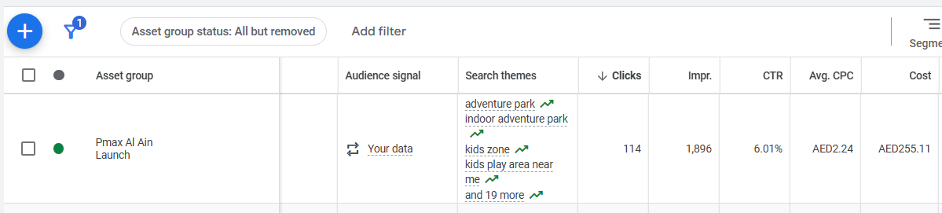

## **3. Search Campaign**

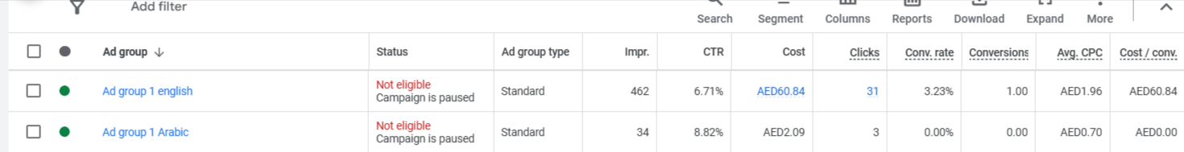

1. Created 2 separate ad groups for English keywords with english ad copies and Arabic keywords with Arabic ads copies.  
2. Arabic ad group has high CTR, but the cost is way to less compared to the english ad group, but still can do A/B testing during scale of the campaigns

## **4. Emailer**

Email was sent to the whole of the database - 46,246 people

Out of which 3,628 people opened the emailer and 19 of them clicked on the emailer.

